REQUEST FOR PARTICIPATION
IN THE IX INTERNATIONAL CONGRESS ON PSYCHOLOGY - SOFIA,
NOVEMBER 13-15, 2020

- ……………………………………………………………………………………..
Name, surname, family
- ……………………………………………………………………………………..
Position, scientific title, degree
- ………………………………………………………………………………………
Place of work
…………………………………………………………………………………………..
Correspondence address, telephone
………………………………………………………………………………………….
Mobile phone, e-mail
4. Form of participation in the Congress:

Mark your wishes and suggestions or add

- Report | - Round table
- Notices | - Seminar/Workshop
- Poster | - Demonstration/Exhibition
- Listener | - Stand
…………………………………………………………………………………………

- Title of the reports, posters, notices with which I will participate
…………………………………………………………………………………………
…………………………………………………………………………………………
…………………………………………………………………………………………
- For a section (specify which section to present your report) …………………………………………………………………………………………
- Author, co-authors
…………………………………………………………………………………………
……………………………………………………………............................................
- Necessary technical means for the presentation:

- Multimedia | - Whiteboard
- Video equipment | - Stand
- Poster | - Other …………………..

- Request for "Pre-Congress / Post-Congress Tour":

- Sofia (+ 45 lv.) | 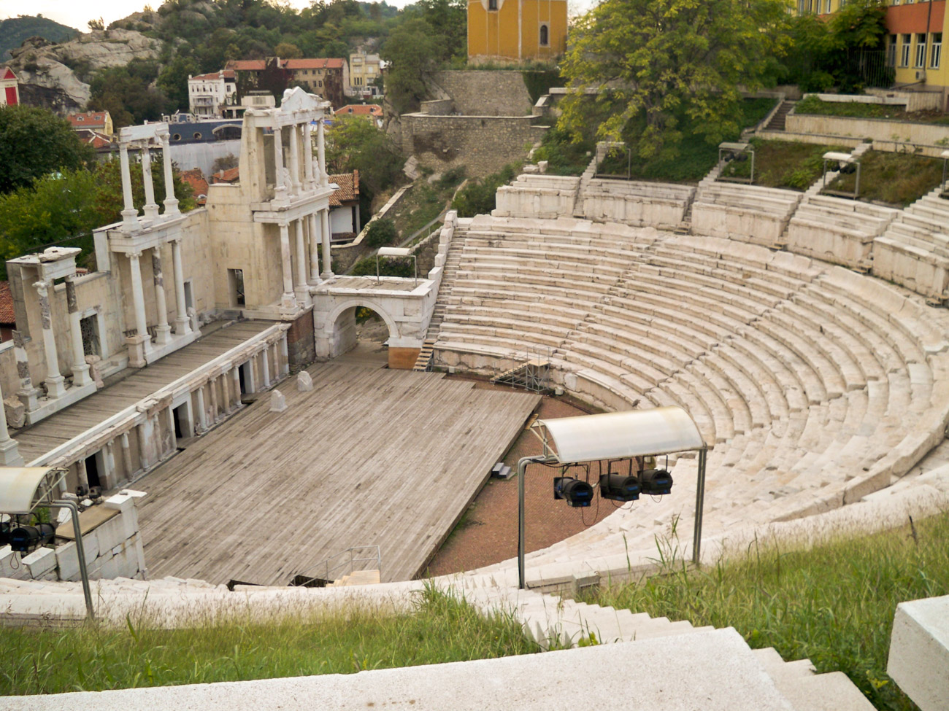  - Plovdiv (+ 68 lv.)
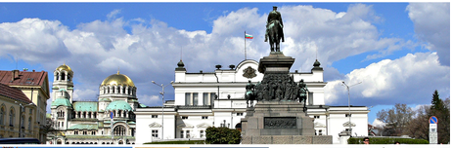

10. Accommodation in a hotel (+88 BGN)
- Yes  Dates: ………………..  ………………………. | - No

Bank account for payment of the participation fee:  BULGARIAN PSYCHOLOGICAL SOCIETY  UBB  IBAN: BG75UBBS88881000117062  BIC UBBSBGSF  Reason for payment: Participation fee – 9 CP 2020 | Address for sending annotations and reports:  Bulgarian Psychological Society  Bulgaria, Sofia – 1606,  14 Lyulin Planina Str., studio 2  e-mail: office@psychology-bg.org  GSM: 0887 426 394; office tel: 02/85 10 999

Full information for the ix international congress on psychology - Sofia 2020:

